CENTRE FOR SOCIAL RECONSTRUCTION

Annual Report 2022-23

FROM THE DIRCTOR:

I recall a saying that goes this way, without first step, there is no challenge; “without direction, there can be no goal; without conviction, no dedication; and without learning, no understandings” Our very first memories, struggles, experiences; more than all the achievements and motivation from different corner of well wishers and supporters since 1974 are still fresh and keep us going with the spirit of commitment. This search toward mainstreaming efforts that focuses on sustainability has not ended yet. We keep moving ahead from motivating to sustaining in areas that are contextual and community based needs.

I am happy to see that CSR has traversed yet another year of its service to the needy and vulnerable communities. Over 49 years have definitely passed through with difficulties, sorrows, worries, failures, and problems. But our achievements, joys, progress and new ventures have certainly enabled us travel until this day.

CSR had played a vital role in mobilizing and motivating the communities with which it works. The support received from various places had equipped the beneficiaries in many capacities. CSR association with the community; NGOs; CBOs; FPO; Government and various global supporters have helped to materialize our goal and objectives. CSR have been a good facilitator in leading women toward empowerment and livelihood efforts; advocacy initiatives; health for all programmes and rural based community enterprises etc.

I am thankful to our General Body/Executive Committee members, NGO friends, well wishers and the community for their unflinching support and solidarity.

Programs

1)
Women Empowerment Prgoramme

To overcome the economic dependence and social subordination, CSR empowers women and supports to increase women’s visibility. Since 1996 CSR pays special attention to the development and empowerment of women in rural and remote areas to Thiruchendure taluk of Tuticorin district.

The target group consists of marginalized women and Palmyra tappers from Tiruchendure, Udangudi and Alwarthirunagri blocks of Tuticorin District.
The objective of the project is to strengthen the socio-economic and educational status of the weaker sections, to empower women and pave way for the holistic and sustainable development of rural people. ICICI Bank is doing major role for the welfare of our SHG members.
CSR promoted women sangamam federation is more effective in ensuring sustainability, equitable distribution of wealth benefit in developing and managing products and services affecting lives of people.
CSR organises trainings on topics such as health, legal matters/rights, gender sensitization, leadership, skill development, managerial skills as well as team-building to the women of SHGs. It has formed 340 SHGs with a membership of 5700 women in 66 villages of Tiruchendur taluk of tuticorin district. These SHG’s have been federated at Panchayat Level and called as Sangamam Women’s federation and registered as a trust under the Indian Trusts act. The Sangamam women federation gives a distinct identify, visibility and strength to its members. From their own funds and bank linkages, Sangamam federation has managed to build assets; it bought its own land, constructed a two-storey building in Tiruchendur town.
3028 members started Income Generation Programme for their livelihood. Sangamam is running health insurance and micro insurance schemes. Leadership qualities and capabilities of women are demonstrated by the performance of federation in dealing with the routine administrative and management aspects and interaction with government department.
CSR has motivated members of SHGs to send their girls to schools. This has improved their education. It also provides career development guidance for girls to choose appropriate courses taking into account their talents and abilities and the marks scored in exams.

problems and improve further and also to enhance the capacity of the staff.
The Sangamam Women’s Federation facilitated by CSR is also facing problems created by vested interests from various political parties. The local political leaders have tried to influence the leaders of Self Help Groups to serve their political interests. CSR has talked this issue by organizing various training programmes continuously and constantly to the federation committee members and Panchayat level federation members.

Current position of the SHGs

Details | Up to Last year | Current Year | Total
No. of SHGs | 483 | 5 | 488
Member | 8476 | 95 | 8571
No. of Loan to embers | 69329 | 3925 | 73254
Savings | Rs. 4,59,50,438.00 | 2,16,90,000.00 | Rs. 6,76,40,438.00
Credit Mobilized | Rs.25,22,37,550.00 | 3,68,19,500.00 | Rs.289057050.00
Credit Revolving loan | Rs.56,70,72,799.00 | 7,13,21,000.00 | Rs.63,83,93,799.00

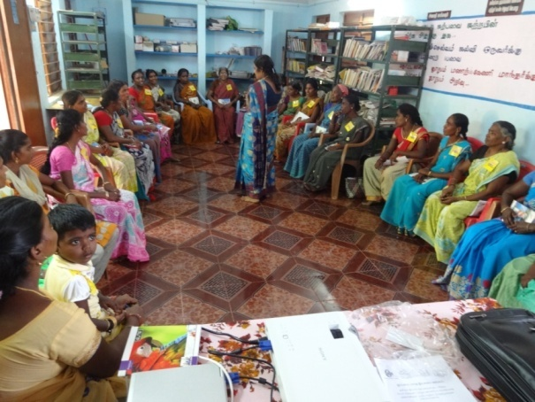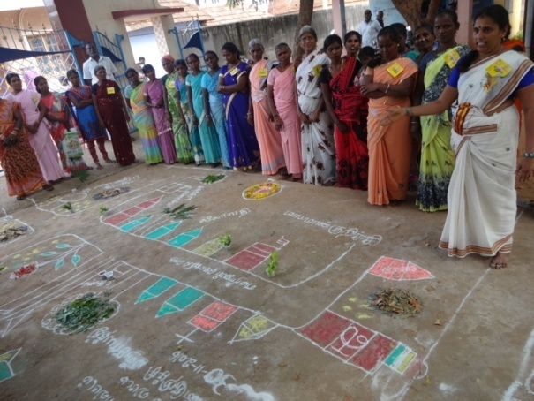

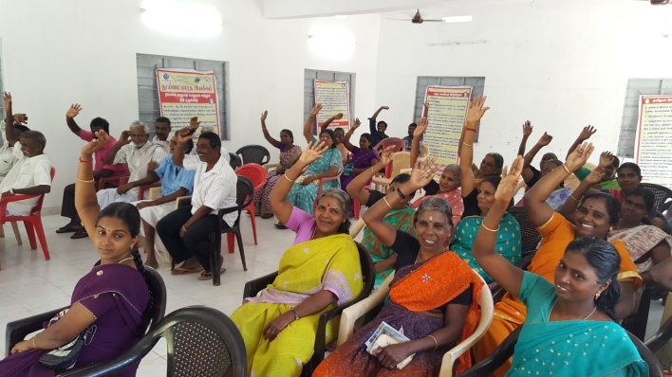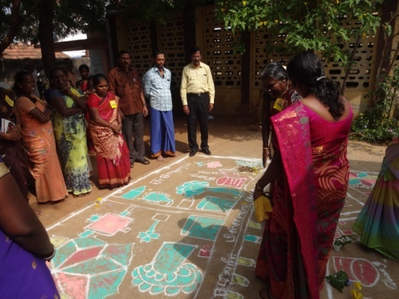

FISHER PRODUCER COMPANY Supported by NABARD
CSR Promoted a Fisher Producer Organization called “South Coast Fisher Producer Company Limited” in the year 2021– supported by NABARD. The project sanctioned in March 2021. South Coast Fisher Producer Company Limited is a Private limited company incorporated on 28 July 2021. It is classified as Non-govt. company (Fisher Producer Company) and is registered at Register of Companies, Chennai.
The Mission of the FPO is “Permanent & Assurance of income, confidential working capital investment for the fishermen and fisherwomen.”
The main objectives to be pursued by the company on its incorporation are:
To involve only in activities relating to those mentioned under Section 378B of Chapter XXIA of the Companies Act, 2013 for the benefit of its members which include, activities relating to fish production, fish harvesting, processing, procurement, peeling, grading, pooling, handling, processing including preserving, dying, distilling, brewing, venting, canning, packaging, warehousing, marketing, selling & exporting of marine and marine related products, shell craft, chilled and frozen fish and to deal with any products resulting from any of the above activities including by- products of such products and any other ancillary

activity to promote any of the foresaid activities or anything ancillary there to including importing of goods or services for the benefit of the members.
Its authorized share capital is Rs. 1,500,000 and its paid up capital is Rs. 100,000 as on 31st March 2022 (7.24 lakhs as on 31st October 2022). Total Members 505 as on 31/10/2022. The membership is increased to 738 (male 388 and Female 350 members)with the share capital of Rs.11,47,000 as on 11.07.2023.and further increased to 811 (male 436 and female 375 members) with the paid up share capital of Rs.12,20,000 as on 9.9.2023.
The FPC is currently undertaking fish pickle production and sales, supporting the fisher community members to purches fishing boat engines, geares, house based hand maid fish nets by the women etc.. The total turnover of the South Coast Fisher Producer Company during 2022-23 is Rs.52,38,038 and profit earned is Rs.1,48,608/. Gram Dukan and Common Service Centre – We have setup Gram Dukan (Rural Mart) at Neerodi village for marketing the products of Women Self Helf Groups (WSHGs). The shop was inaugurated by Mr.Ramalingam, DDM, NABARD on 23rd March 2023. The FPC have also setup hand maid fish-net making unite among women at Neerody village. 60 women are getting benefits in the unit.
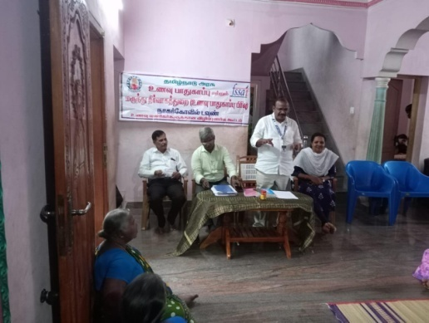
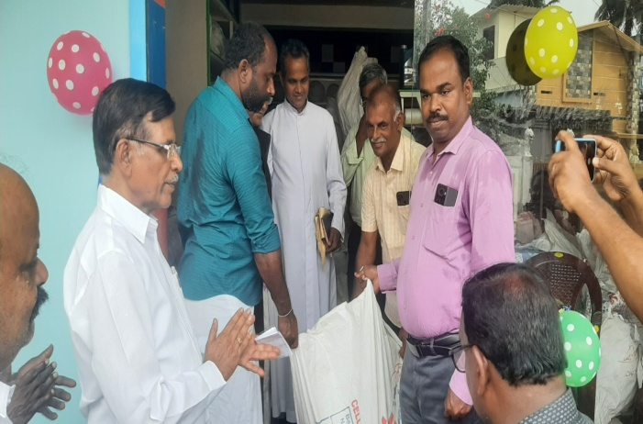

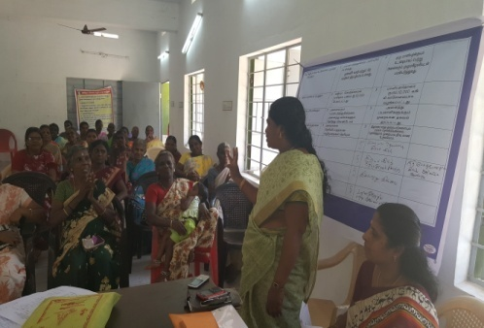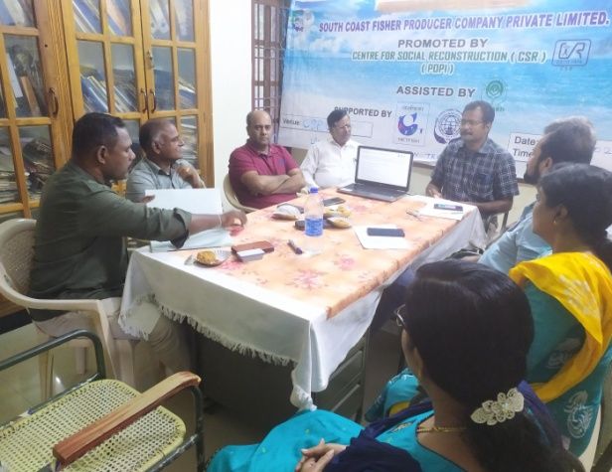

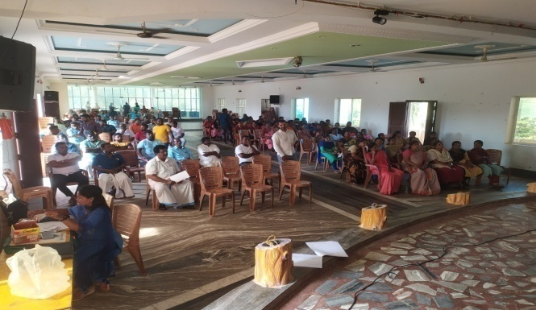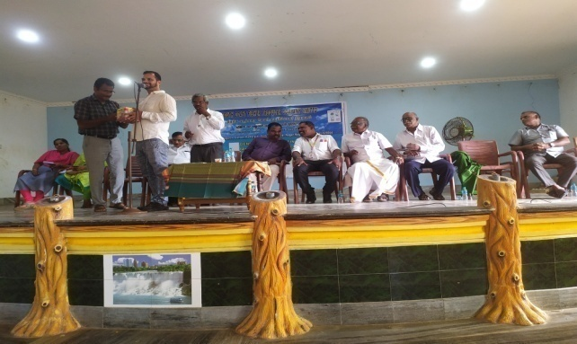

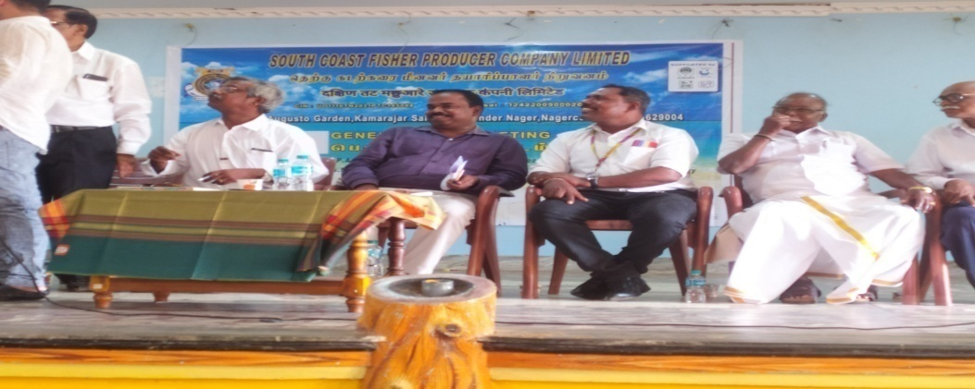

Slab of grass salary (in Rs.) Plus benefits paid to staff(per month) | Male staff | Female staff | Total Staff
5000 - 10000 |  | 4 | 4
10000 - 25000 | 1 | 2 | 3
Total | 1 | 6 | 7

RECEIPTS AND PAYMENTS ACCOUNT FOR THE YEAR ENDED 31.03.2023

Particulars | Receipts | Payments
Opening Balance | 6,18,425.28
Grants Received | 1,47,250.00
Other Receipts | 2,25,761.00
Bank Interest | 13,396.00
SHG Development Programme | 13,64,637.00
Administrative Expenses |  | 4,01,781.00
Programme Expenses |  | 2,11,330.00
Other Expenses |  | 1,48,728.00
SHG Prog. Implementation Exp. |  | 6,64,817.00
NABARD Project |  | 1,49,390.00
Advances for programmes |  | 25,000.00
Shed for office extension |  | 4,02,090.00
Tax deducted at Source |  | 66,933.00
Closing Balances |  | 2,99,402.28
Total | 23,69,469.28 | 23,69,469.28

Remuneration and Travel by the Board members and staff:

No travel reimbursements of any kind were trade by Board members attending.
Remuneration of highest paid staff: Rs.16000/-
Remuneration of lowest paid staff Rs.7500/-
Total cost of domestic travel by the director is Rs. 47909/-
Domestic travel by all staff. Rs. 115500/-
No international travel by all personal including staff, volunteers and board members.

List of Executive Committee Members

Sr.No | Name | Position in the Board | Total amount paid in last financial year (Rs.) | Form of payment  Salary/Consultancy/Honorarium/Sitting Fees/other(Specify)
1 | Mrs.C.Vijaya Sutha | President | Zero
2 | Mr.Neelam athumayan | Vice-president | Zero
3 | Dr.T.S.Ramkumar | General Secretary | 2,05,000.00 | Honorarium & field visit travel.
4 | Mr.George Josep | Joint Secretary | Zero
5. | Mr.H.Chandra Sekar | Treasure | Zero
6. | Mrs.Vasanthi | Member | Zero
7. | Mrs.Devi Jegan | Member | Zero

